Requirements Engineering

Assignment 3 – User Stories, Use Case Diagrams and Use Case Templates

Group 44 – SA: Paulien Wisselink

Wout van den Berg – s1014417

8 June 2018

# User stories

There are different stakeholders that need to be taken into account for the Seats and More chain. Not all stakeholders are relevant for the project with the tablet system. The three most important stakeholders for the project are the customers, sales staff and the store managers.

## User stories of customers

* As a customer, I want to be able to find specific products faster so that I can spent less time in the store.
* As a customer, I want to be able to get the help of the sales staff quickly so that I don’t spent too much time looking for someone.
* As a customer, I want to be able to visit the store without the need for a guidance device so that there are no restrictions.

## User stories of sales staff

* As a sales staff employee, I want less customers crowding at one place so that I can actually help the customer that I’m currently helping without interruptions.
* As a sales staff employee, I want to find customers that need any help quickly so that I don’t waste time doing nothing.
* As a sales staff employee, I want to be able to help the customers so that I don’t get replaced.

## User stories of store managers

* As a store manager, I want to have less traffic problems in the store so that there can be more people in the store at the same time.
* As a store manager, I want that customers leave with a positive feeling about Seats and More so that they might come back in the future.
* As a store manager, I want to collect some data of customers so that the data can to be taken into account when making decisions about the store.

## Priorities and estimated effort

The first user story of the customers says that customers want to spend less time in the store, one user story of the sales staff says that there is need for less crowded places in the store and one user story of the store managers says that there is need for less traffic problems in the store. In the interview that we held with a store manager it was clear that the most important thing was that there were less traffic problems in the store. Therefore these user stories will have the highest priority. This problem might not be the easiest to solve because it requires the tablet guidance system to navigate the customers through the store in such a way that there won’t be traffic problems, which might require different routes for different customers. Then the problem that gets the second priority is getting sales staff employees faster to customers that need help. All that this requires is a button on the tablet that will alert someone from the sales staff, which doesn’t require much effort to implement. To be able to visit the store without the use of the tablet device will also get high priority, because the tablet device shouldn’t make the store lose any customers. This is also very easy to implement because the store currently doesn’t have a tablet device so there is nothing that should be changed for this feature.

The other user stories get less priority because the main focus is preventing the traffic problem. The other user stories are less in the scope of this project because the tablet device can shouldn’t replace the sales staff such as said in the interview with the store manager. The tablet should only be an additional feature to enhance the shopping experience for the customers but it shouldn’t give any restraints to the customers.

# Use case diagram and templates

## Top-level use-case diagram

This is a top-level use-case diagram with four stakeholders: customers, sales staff, cashiers and the store managers. This use-case diagram only takes customers into account that use the tablet devices.

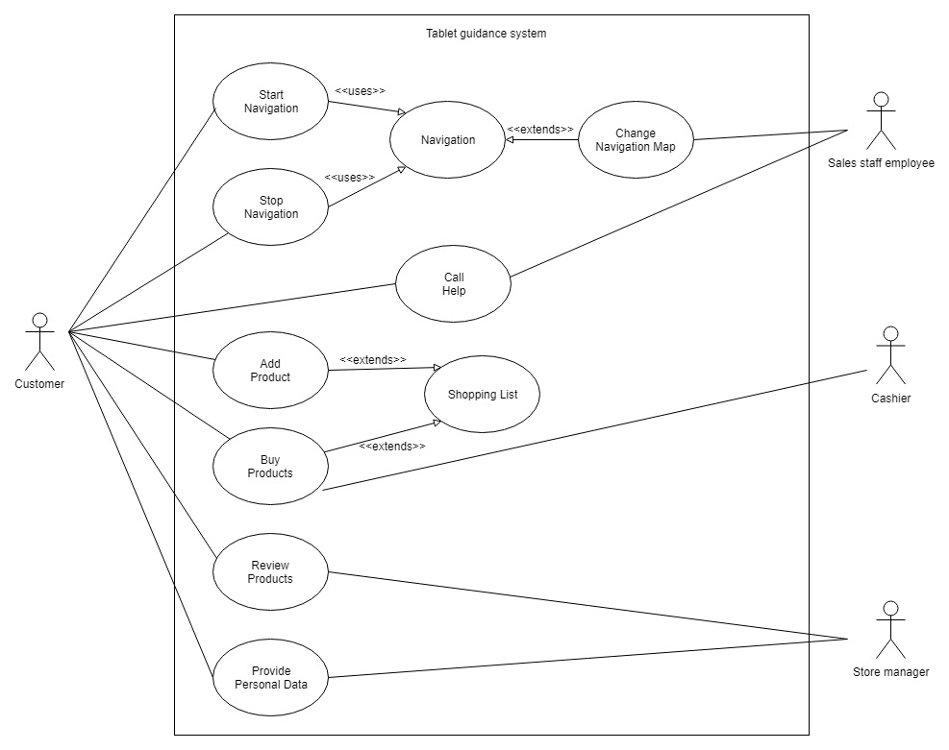

## Use case templates

|  |  |
| --- | --- |
| ID and name | Start navigation |
| Primary actor | Customer |
| Description | Starts the navigation on the tablet device |
| Trigger | User presses start button on the tablet device |
| Preconditions | Tablet is turned on and navigation hasn’t started already |
| Postconditions | Navigation starts |
| Normal flow | 1. Customer presses start button 2. Navigation starts |
| Alternative flows | 1. Customer presses start button 2. Doesn’t start 3. Customer gets another device |
| Exceptions | Device gets broken or loses power |
| Priority | High priority |
| Frequency of use | Every time a customer walks into the store that wants to use the tablet device |

|  |  |
| --- | --- |
| ID and name | Stop navigation |
| Primary actor | Customer |
| Description | Stops the navigation on the tablet device |
| Trigger | User presses stop button on the tablet device |
| Preconditions | Tablet is turned on and navigation is running |
| Postconditions | Navigation stops |
| Normal flow | 1. Customer presses stop button 2. Navigation stops |
| Alternative flows | 1. Customer forgets to stop navigation 2. Sales staff stops navigation |
| Exceptions | - |
| Priority | Low priority |
| Frequency of use | Every time a customer that used the tablet is done visiting the store |

|  |  |
| --- | --- |
| ID and name | Navigation |
| Primary actor | No direct actors |
| Description | Navigation system itself |
| Trigger | Tablet request navigation |
| Preconditions | Navigation has map of store |
| Postconditions | - |
| Normal flow | Provides navigation |
| Alternative flows |  |
| Exceptions | Gps system is shut down |
| Priority | High priority |
| Frequency of use | Every time a customer uses tablet |

|  |  |
| --- | --- |
| ID and name | Change navigation map |
| Primary actor | Sales staff employee |
| Description | Changes default route of the navigation and adds/removes products from the route |
| Trigger | Sales staff employee updates navigation map |
| Preconditions |  |
| Postconditions | Navigation map is updated |
| Normal flow | 1. Sales staff employee adds/removes product to the route 2. Route gets updated |
| Alternative flows |  |
| Exceptions | Navigation map doesn’t get updated |
| Priority | High priority |
| Frequency of use | Every time a sales staff employee updates the navigation map |

|  |  |
| --- | --- |
| ID and name | Call help |
| Primary actor | Customer and sales staff |
| Description | Customer asks for help off a sales staff employee |
| Trigger | User presses alert sales staff button |
| Preconditions | Tablet is turned on and navigation has started |
| Postconditions | Sales staff employee is alerted |
| Normal flow | 1. Customer presses help button 2. Sales staff is alerted 3. Sales staff helps customer |
| Alternative flows | 1. Customer presses help button 2. Sales staff is alerted 3. No sales staff employee available 4. Customer is put in a waiting list |
| Exceptions | Device gets broken or loses power |
| Priority | High priority |
| Frequency of use | Every time a customer presses the help button on the tablet device |

|  |  |
| --- | --- |
| ID and name | Shopping list |
| Primary actor | Customer |
| Description | List of products that the customer has added to the shopping list |
| Trigger | Product gets added or removed from the shopping list |
| Preconditions | Tablet has power and navigation is running |
| Postconditions |  |
| Normal flow | Contains list of products |
| Alternative flows |  |
| Exceptions | Device gets broken or loses power |
| Priority | Medium priority |
| Frequency of use | Every time a customer adds a product to the shopping list or wants to buy the products on the shopping list |
| ID and name | Add product |
| Primary actor | Customer |
| Description | Customer adds a product to the shopping list |
| Trigger | User presses button to add product to shopping list |
| Preconditions | Tablet is turned on and navigation has started |
| Postconditions | Product is added to the shopping list |
| Normal flow | 1. User presses button to add product 2. Product is added to shopping list |
| Alternative flows | 1. User inserts how many times a specific product needs to be bought 2. Products are added to shopping list |
| Exceptions | Device gets broken or loses power |
| Priority | Medium priority |
| Frequency of use | Every time a customer adds a product to the shopping list |

|  |  |
| --- | --- |
| ID and name | Buy products |
| Primary actor | Customer |
| Description | Customer buys products from shopping list at cash desk |
| Trigger | User is at cash desk |
| Preconditions | Tablet is turned on and shopping list contains products |
| Postconditions | Products are payed |
| Normal flow | 1. Customer is at cash desk 2. Cashier sees products on shopping list 3. Cashier gets bill 4. Customer pays for products |
| Alternative flows | 1. Customer is at cash desk 2. Cashier sees products on shopping list 3. Cashier adds discount 4. Cashier gets bill 5. Customer pays for products |
| Exceptions | Device gets broken or loses power |
| Priority | Medium priority |
| Frequency of use | Every time a customer buys products using the shopping list on the tablet device |

|  |  |
| --- | --- |
| ID and name | Review products |
| Primary actor | Customer and store manager |
| Description | Customer reviews products that the customer sees in the store |
| Trigger | Product presses review product button |
| Preconditions | Tablet is turned on and navigation is running |
| Postconditions | Product is reviewed |
| Normal flow | 1. Customer presses review product button 2. Customer reviews product 3. Customer submits review |
| Alternative flows | 1. Customer presses review product button 2. Customer cancels review |
| Exceptions | Device gets broken or loses power |
| Priority | Medium priority |
| Frequency of use | Every time a customer presses the review product button |

|  |  |
| --- | --- |
| ID and name | Provide personal data |
| Primary actor | Customer and store manager |
| Description | Customer can fill in personal data, for example age and city where customer lives |
| Trigger | Customer is at the place where tablets get returned |
| Preconditions | Tablet is turned on and navigation is running |
| Postconditions | Personal data is provided |
| Normal flow | 1. Navigation detects customer is at the place where tablets get returned 2. Tablet asks customer for personal data 3. Customer provides data |
| Alternative flows | 1. Navigation detects customer is at the place where tablets get returned 2. Tablet asks customer for personal data 3. Customer refuses to provide data |
| Exceptions | Device gets broken or loses power |
| Priority | Medium priority |
| Frequency of use | Every time a customer presses the review product button |

## Expanded use case

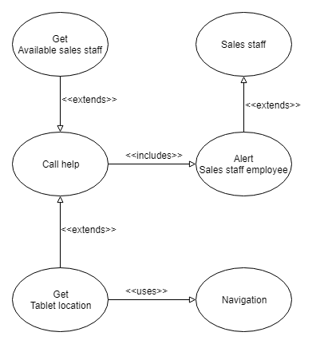

# Discussion

The user stories and use cases have an impact on the things that we already discussed in the vision and scope document. Some things that the user stories and use cases say were already thought of in the vision and scope document.

First of all the button to ask for the help of a sales staff employee was already thought of. Although it wasn’t made in much detail yet. Now with the lower-level use case diagram on the call help button on the device it is further worked out. Something that wasn’t thought of before is that the location of the user should be sent to the sales staff and that there must be checked whether there is a sales staff employee available or not. Like said in the template for the use cases if there is no available sales staff employee the customer can be put on a waiting list so that there will come a sales staff employee to help the customer as soon as one is available and at a reasonable distance from the customer.

Secondly a thing that the user stories and use cases show better than the vision and scope document is that what kind of buttons should be on the tablet device. For example the tablet should have a button to call a sales staff employee, add/remove items to the shopping list and to start/stop the navigation. At a later stage of designing the tablet device there must still be put some more thought into the buttons and how and when to show them.

For the navigation system the user stories and use cases are on the same line as the vision and scope document. One thing that is added in the use cases is that there needs to be a start and stop button for the navigation system, so that the customer can start the route.

The user stories didn’t mention anything about the wish list feature that was described in the vision and scope document. This is a feature that isn’t that important for any of the stakeholders so probably based on the user stories and use cases this feature won’t be implemented in the final version of the product.

Furthermore the main focus of the project remains the same, reducing the “traffic jams” that are in the stores of Seats and More. For all the stakeholders this is one of the highest priorities and therefore the projects priority should remain to reduce the traffic problems.